Budget Challenge teaches kids finance
Posted on April 20, 2012 by Laura Baverman
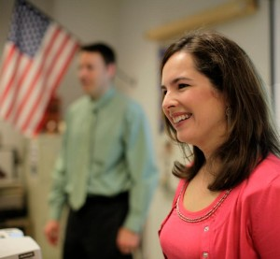
As an undergraduate environmental science and public policy major at Harvard University, Palmira Buten found herself in credit card debt, mismanaging her cash flow and bouncing checks.
Dave Buten was a chemical engineering student at Purdue University when he first bounced a check. “How could that happen when the ATM said he had money in his account?”, he questioned.
“I was smart,” Palmira Buten says. “But you just don’t know this stuff.”

The married couple, of Mount Lookout, has dedicated the last six years to building a business that helps high school students be prepared for the financial commitments of the real world. Their online simulation called Budget Challenge, launched in 2008, is now used by teachers in 65 schools in 20 states and as far as Nepal. The company is preparing for faster growth as states around the nation consider or pass legislation that requires personal finance education in classrooms for the first time.

Palmira and Dave Buten meet with students using Budget Challenge at St. Ursula Academy. Photo credit: Liz Dufour/The Enquirer
Ohio graduating seniors will be the newest students around the nation to meet the requirement. Beginning this fall, high school students must complete within four years a curriculum of financial literacy education, including the consequences of their choices about budgets, savings, credit, philanthropy, interest rates and investments. Budget Challenge addresses all of those topics through fun and educational competitions in the classroom.
“We think people learn pretty well in today’s society by doing,” says Dave Buten, 37, and a Cincinnati Children’s Hospital business director by day. “The problem is that it’s getting too expensive and too risky with all the bank fees. We’re taking the real world learning and putting it into a classroom.”
The couple began to brainstorm entrepreneurial ideas when they met as MBA students at Indiana University. They later joined Deloitte Consulting to help other companies grow and understand their businesses. Palmira, now 38, eventually moved on to a vice president of finance role at Fifth Third Bank. She saw firsthand the impact of the mortgage crisis on families.
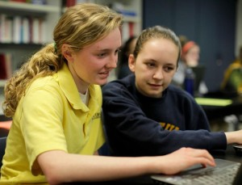
“We were amazed at how much we were still learning about money even after getting MBAs and buying our second house,” she says. “We wondered if people in America ever learn that stuff. And if you don’t learn the hard way, is is there a better way?”
In 2006, the Butens began extensive research into the personal finance education options for youth. Finding only offerings by banks that prescribe a course of action, they began to create in Microsoft Excel a real world simulation in which high school students are given a fake bank account, salary, apartment, utilities, car payment, insurance and credit card, and responsibility for managing all of it.
The students would receive fake bills in the mail and return those bills with fake checks. Budget Challenge would track the students’ financial decisions, awarding points for paying bills on time and keeping a healthy checking account balance. It detracted points for missing payments and incurring penalties.
Emily Englehardt, left, and Lauren Boeckermann, both juniors at St. Ursula Academy, are second and third place in the Budget Challenge. Photo credit: Liz Dufour/The Enquirer

The Buten’s filed a patent in 2006. Though it’s still pending, they’ve yet to identify a true competitor.
Dave Buten’s alma mater St. Xavier High School agreed to test out Budget Challenge in spring 2008. Feedback from math of finance teacher Barb Hausladen prompted the pair to take the entire simulation online. Each year, they survey teachers and students and then revamp the program to make it as much like online banking as possible, with more functionality for students and better reporting systems for teachers
Teachers also asked that the Butens add a savings option. And so the couple created a 401K plan, awarding students points for dollars saved for retirement from the biweekly pay.
“They could learn about matching funds and how changing their percentages could increase their savings and have a tax benefit,” says Marti Butz, a college prep economics teacher at St. Ursula Academy, one of eight schools in this region to use the program.
A key finding during the test was that Budget Challenge forced, often for the first time, parents to have meaningful conversations with their kids about money.
“It’s stuff that everybody assumed the kids would know, but they don’t,” Hausladen says. “I teach bright kids, but too many were coming back to me and saying they’re in debt with charge cards and college loans.”
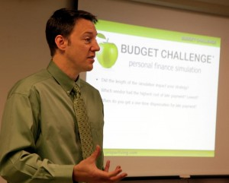
Sometimes fees snowball during the challenge. A student bounces a check, incurs a late fee and a returned check fee all at once. Budget Challenge also plots unexpected occurrences like a car wreck. Students who bought auto insurance with a low premium but high deductible must write a larger check than those that paid upfront for insurance with a low deductible.
“They can get wildly different results,” Palmira Buten says. To help the kids learn from their mistakes, the Butens offer online customer service, responding to students’ questions within 24 hours. They often host contests between local schools, awarding the winning class with a pizza party.
A big learning curve for the couple has been the lengthyand varying decision-making and purchasing processes at schools. Budget Challenge typically costs $20-$25 per student for the months-long simulation, which includes materials and quizzes for teachers. Some schools must get approval from principals or district administrators to use the program, and then must find a way to pay for it.
They’ll pass the fee along to parents, or include it in a student’s tuition. Grants or sponsorship dollars may fund the program. Sometimes teachers pay for the materials out of their own budgets.
But the process is getting faster as word spreads.
Dave Buten, a co-founder of Budget Challenge, presents to St. Ursula Academy students. Photo credit: Liz Dufour/The Enquirer
“It used to be us knocking on so many doors to get in and now they reach out to us,” Palmira Buten says.
The Butens have been preparing for the coming spike as teachers and schools prepare to meet the coming requirements. Two teachers on the committee creating Ohio’s curriculum already use Budget Challenge in their classrooms, and advocate it for statewide use.
The Butens have built a backend technology platform that can support over a million students, and will soon launch a version of the site that enables use by iPad, iPhone and other mobile devices. They expect to soon hire outside sales people. They’ll make a profit for the first time in 2012.
The couple must soon decide whether to seek outside capital to grow the business faster. They’re worried about competition, but hesitant to lose control.
“This business needs to make money to do more good,” Dave Buten says. “But we have a soft spot too. If there’s a teacher that wants to do this and is having trouble, we’ll give free demos. We don’t want to lose that.”
Laura Baverman is the Innovations columnist for the Cincinnati Enquirer. It is her job to find - and then tell - the best stories about up-and-coming local businesses, entrepreneurs and ideas.
Palmira and Dave Buten meet with students using Budget Challenge at St. Ursula Academy. Photo credit: Liz Dufour/The EnquirerImage 1 of 3
http://enterchange.cincinnati.com/2012/04/20/budget-challenge-teaches-kids-finance/

